http://kingsoftoffice.desk.com/customer/portal/articles/1550485-change-row-height-and-column-width-of-a-table

Change the row height
You can quickly modify the row height by using the mouse or the Table Properties dialogue box in the Table Tools tab. Here you can specify the exact row height.
Change the Row Height by the Mouse
The steps are as follows:
Step 1 Move the cursor to the bottom border line of the row whose height you want to adjust. The cursor will then change into a double-sided arrow.
Step 2 Press the left mouse button to drag up and down. A dotted line will appear indicating the intended new line height shown as below:
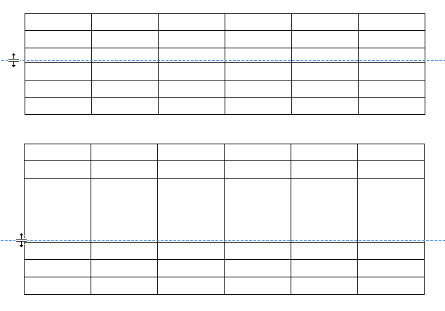
Figure 1 Change row height by the mouse
Step 3 Once you are satisfied with the new row height, simply release the left mouse button.
Change the Row Height by the Table Properties Dialogue Box
The steps are as follows:
Step 1 Select the desired number of rows for which you want to adjust the height. Go to the Table Tools tab.
Step 2 Click the Table Properties icon and open the Table Properties dialog box.
Step 3 Select the Row tab. Shown as below:
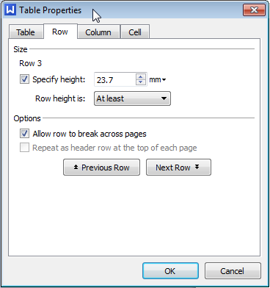
Figure 2 The Row tab
Step 4 Choose the Specify height check box and set the exact height in the text box to the right.
Step 5 The Row height section offers two options: At least and Exactly.
- 1. If you select At least, the row height will always be the minimum possible and will automatically adjust to the content.
- 2. If you select Exactly, the row height will be a fixed value. If the contents in the cell exceed this fixed height, Kingsoft Writer will not display or print the exceeded contents.
Step 6 In the Options section, there are two check boxes: Allow row to break across pages and Repeat as header row at the top of each page.
- 1. If you select the Allow row to break across pages check box, any overly long lines will be split and displayed in separate pages, as opposed to having the whole line moved to the next page.
- 2. The Repeat as header row at the top of each page check box is only effective when adjusting the row height from the first row.
Step 7 Click either the Previous Row button or the Next Row button will allow you to set the height of the other rows.
Step 8 Click the OK button to complete the operation.

Change column width
You can quickly Change the column width by using the mouse or the Table Properties icon in the Table Tools tab. Here you can specify the exact column width.
Change Column Width by the mouse
The steps are as follows:
Step 1 Move the cursor to the right border line of the column whose width you want to adjust. The cursor will then change into a double sided arrow.
Step 2 Hold the left mouse button to drag to the right or to the left. A dotted line will appear indicating the intended width:
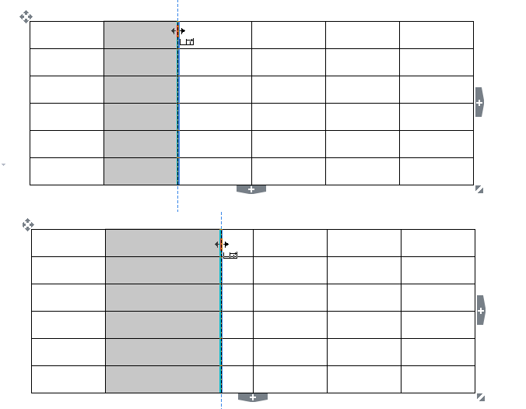
Figure 3 Change the column width by the mouse
Step 3 When you are satisfied, simply release the mouse.
Tips:
- 1. To Change the width of a certain cell, select a cell and drag the right hand border line to change the width of the cell.
- 2. Kingsoft Writer provides the automatic table border adjustment function when the selected cell border moves closer to the adjacent cell border. It will automatically stop when approaching the minimum space, shown as below, which greatly improves the efficiency of adjusting the borders.
- 3. Pressing the Shift key while holding the left mouse button will only alter the column width of the selected cell without affecting the adjacent column width.

Figure 4 Change the table automatically
Change the Column Width by the Table Properties Dialogue Box
The steps are as follows:
Step 1 Place the insertion point in the cell within the column of which you wish to adjust the width or select one row or several rows that you want to Change, and go to the Table Tools tab.
Step 2 Click the Table Properties icon and open the Table Properties dialog box.
Step 3 Select the Column tab shown as below:
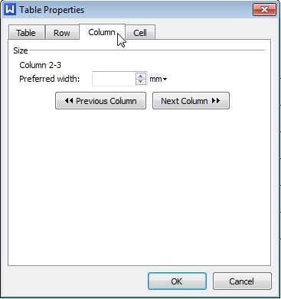
Figure 5 The Column tab
Step 4 Choose the width in the text box to the right of the Preferred width section.
Step 5 Click the Previous Column button or the Next Column button to set the width of another column.
Step 6 Click OK to finish.
Tips: Kingsoft Writer can automatically adjust the column width according to the size of the window. Simply place the insertion point in the table, click the AutoFit icon in the Table Tools tab, and choose the AutoFit to Window option in the drop-down menu.

